**Deploying and Containerizing an existing on-premises app using docker and Azure Container Registry.**

**Migration using Docker Containers**

In addition to our other tools we can migrate to the Azure App Service by leveraging Docker and the Azure Container service. This allows for a stepped migration from an app hosted on an on-premises webserver, to an on-premises docker instance, then deploying to the Azure App Service. Depending on your needs this may be a better option for your development, and testing. We will be demonstrating the process with a basic PHP connecting to a MySQL backend. First we will deploy the app locally, then migrate the database to Azure, connect the app to the database, migrate the app to a container, then deploy the container on the Azure App Service

# **Prerequisites**

To complete this tutorial:

* [Install Git](https://git-scm.com/)
* [Install PHP 5.6.4 or above](https://php.net/downloads.php)
* [Install Composer](https://getcomposer.org/doc/00-intro.md)
* Enable the following PHP extensions Laravel needs: OpenSSL, PDO-MySQL, Mbstring, Tokenizer, XML
* [Install and start MySQL](https://dev.mysql.com/doc/refman/5.7/en/installing.html)
* A workstation with Docker installed and Visual Studio Code with Docker Extension.
* [An Azure container registry.](https://docs.microsoft.com/en-us/azure/container-registry/container-registry-get-started-portal)

# **Prepare local MySQL**

In this step, you create a database in your local MySQL server for your use in this tutorial.

**Connect to local MySQL server**

1. In a terminal window, connect to your local MySQL server. You can use this terminal window to run all the commands in this tutorial.

mysql -u root -p

If you're prompted for a password, enter the password for the root account. If you don't remember your root account password, see [MySQL: How to Reset the Root Password](https://dev.mysql.com/doc/refman/5.7/en/resetting-permissions.html).

If your command runs successfully, then your MySQL server is running. If not, make sure that your local MySQL server is started by following the [MySQL post-installation steps](https://dev.mysql.com/doc/refman/5.7/en/postinstallation.html).

**Create a database locally**

1. At the mysql prompt, create a database.

CREATE DATABASE sampledb;

Exit your server connection by typing quit.

# **Create a PHP app locally**

In this step, you get a Laravel sample application, configure its database connection, and run it locally.

# **Clone the sample**

In the terminal window, cd to a working directory.

1. Run the following command to clone the sample repository.

git clone <https://github.com/Azure-Samples/laravel-tasks>

1. cd to your cloned directory. Install the required packages.

cd laravel-taskscomposer install

## **Configure MySQL connection**

1. In the repository root, create a file named *.env*. Copy the following variables into the *.env* file. Replace the *<root_password>* placeholder with the MySQL root user's password.

APP_ENV=local

APP_DEBUG=true

APP_KEY=SomeRandomString

DB_CONNECTION=mysql

DB_HOST=127.0.0.1

DB_DATABASE=sampledb

DB_USERNAME=root

DB_PASSWORD=<root_password>

For information on how Laravel uses the *.env* file, see [Laravel Environment Configuration](https://laravel.com/docs/5.4/configuration#environment-configuration).

## **Run the sample locally**

1. Run [Laravel database migrations](https://laravel.com/docs/5.4/migrations) to create the tables the application needs. To see which tables are created in the migrations, look in the *database/migrations* directory in the Git repository.

php artisan migrate

1. Generate a new Laravel application key.

php artisan key:generate

1. Run the application.

php artisan serve

Navigate to <http://localhost:8000> in a browser. Add a few tasks in the page.

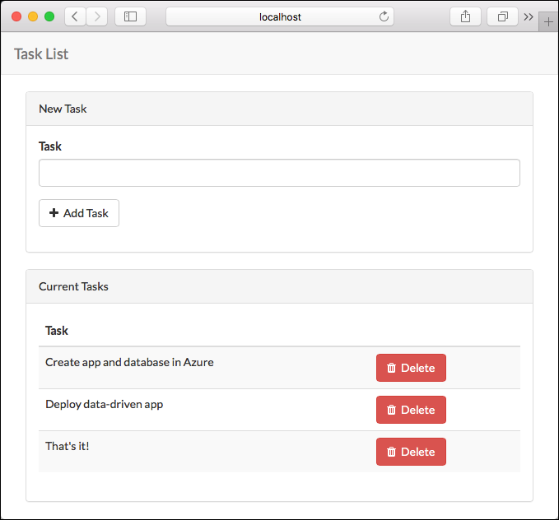

To stop PHP, type Ctrl + C in the terminal

# **Create an Azure Database for MySQL server**

Our next task is to create a MySQL database in Azure. You create an Azure Database for MySQL server with a defined set of [compute and storage resources](https://docs.microsoft.com/en-us/azure/mysql/concepts-compute-unit-and-storage). You create the server within an [Azure resource group](https://docs.microsoft.com/en-us/azure/azure-resource-manager/resource-group-overview).

Follow these steps to create an Azure Database for MySQL server:

1. Select **Create a resource** (+) in the upper-left corner of the portal.
2. Select **Databases** > **Azure Database for MySQL**. You can also enter **MySQL** in the search box to find the service.
3. 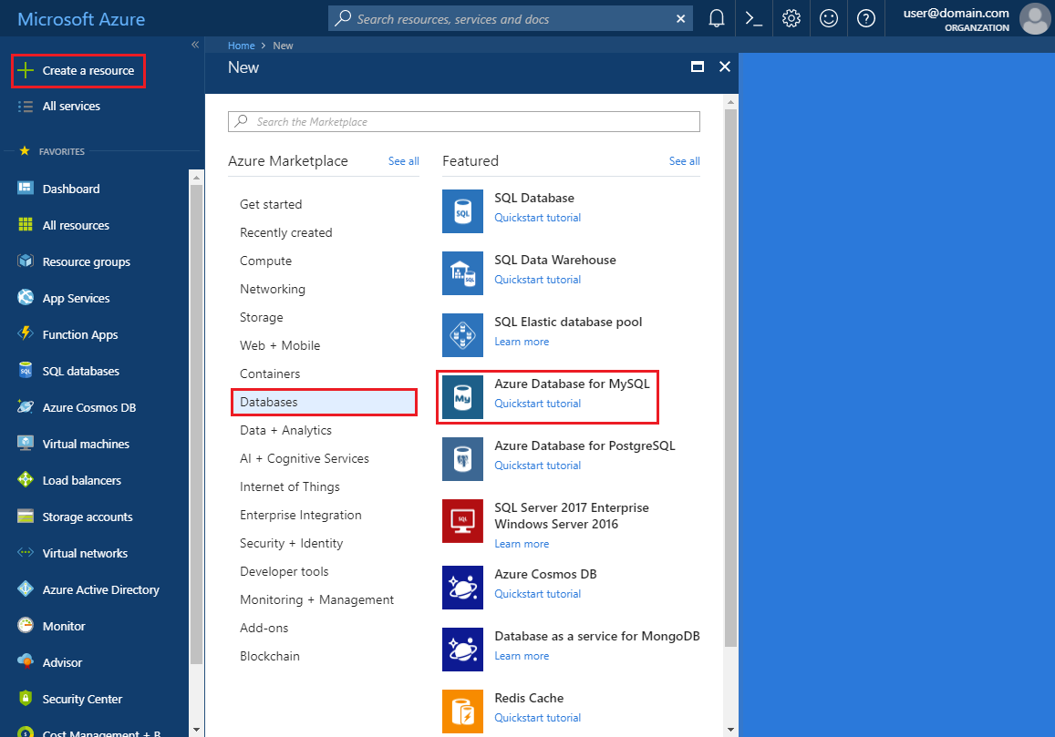
4. Fill out the new server details form with the following information:
5. 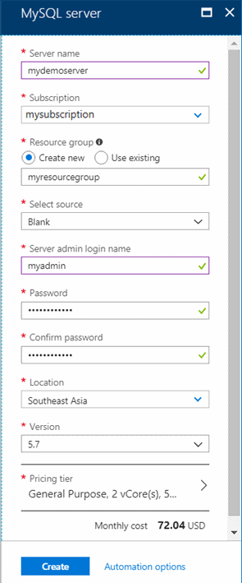

|  |  |  |
| --- | --- | --- |
| **Setting** | **Suggested value** | **Field description** |
| Server name | Unique server name | Enter a unique name that identifies your Azure Database for MySQL server. |
| Subscription | Your subscription | Select the Azure subscription that you want to use for your server. |
| Resource group | *myresourcegroup* | Provide a new or existing resource group name. |
| Select source | *Blank* | Select *Blank* to create a new server from scratch. |
| Server admin login | myadmin | A sign-in account to use when you're connecting to the server. The admin sign-in name cannot be **azure_superuser**, **admin**, **administrator**, **root**, **guest**, or **public**. |
| Password | *Your choice* | Provide a new password for the server admin account. It must contain from 8 to 128 characters. |
| Confirm password | *Your choice* | Confirm the admin account password. |
| Location | *The region closest to your users* | Choose the location that is closest to your users or your other Azure applications. |
| Version | *The latest major version* | The latest major version (unless you have specific requirements that require another version). |
| Pricing tier | **General Purpose**, **Gen 5**, **2 vCores**, **5 GB**, **7 days**, **Geographically Redundant** | The compute, storage, and backup configurations for your new server. Select **Pricing tier**. Next, select the **General Purpose** tab. *Gen 5*, *4 vCores*, *100 GB*, and *7 days* are the default values for **Compute Generation**, **vCore**, **Storage**, and **Backup Retention Period**. You can leave those sliders as is. |

1. 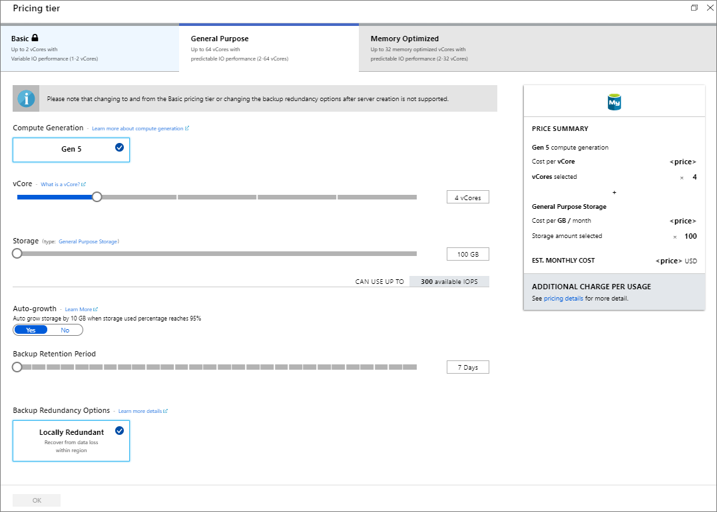
2. Select **Create** to provision the server. Provisioning can take up to 20 minutes.
3. Select **Notifications** on the toolbar (the bell icon) to monitor the deployment process.
4. By default, the following databases are created under your server: **information_schema**, **mysql**, **performance_schema**, and **sys**.

# **Migrate the Database**

## **Create a backup file from the command-line using mysqldump**

1. To back up an existing MySQL database on the local on-premises server or in a virtual machine, run the following command:

$ mysqldump --opt -u [uname] -p[pass] [dbname] > [backupfile.sql]

The parameters to provide are:

* [uname] Your database username
* [pass] The password for your database (note there is no space between -p and the password)
* [dbname] The name of your database
* [backupfile.sql] The filename for your database backup
* [--opt] The mysqldump option

For example, to back up a database named 'sampleDB' on your MySQL server with the username 'testuser' and with no password to a file sampleDB _backup.sql, use the following command. The command backs up the testdb database into a file called sampleDB _backup.sql, which contains all the SQL statements needed to re-create the database.

$ mysqldump -u root -p sampleDB > sampleDB_backup.sql

## **Create a database on the target Azure Database for MySQL server**

Create an empty database on the target Azure Database for MySQL server where you want to migrate the data. Use a tool such as MySQL Workbench. The database can have the same name as the database that is contained the dumped data or you can create a database with a different name.

1. To get connected, locate the connection information in the **Overview** of your Azure Database for MySQL.

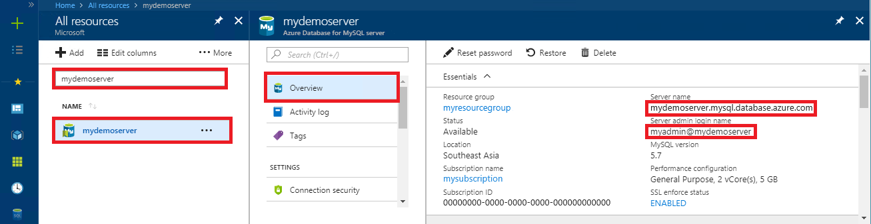

1. Add the connection information into your MySQL Workbench.

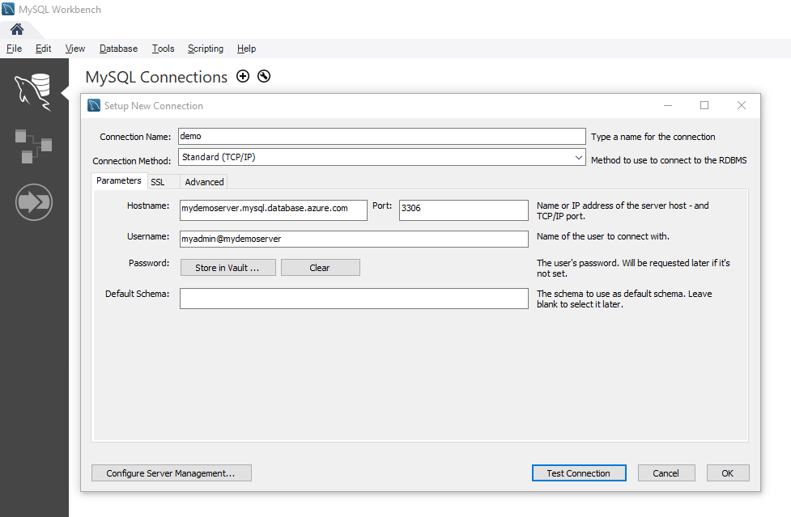

## **Restore your MySQL database using command-line or MySQL Workbench**

Once you have created the target database, you can use the mysql command or MySQL Workbench to restore the data into the specific newly created database from the dump file.

mysql -h [hostname] -u [uname] -p[pass] [db_to_restore] < [backupfile.sql]

In this example, restore the data into the newly created database on the target Azure Database for MySQL server.

$ mysql -h mydemoserver.mysql.database.azure.com -u myadmin@mydemoserver -p testdb < sampleDB _backup.sql

# **Change ENV file to connect to Azure**

Now that you have created the Azure Database you can connect your web app by modifying the ENV file with the connection details you used in the previous steps.

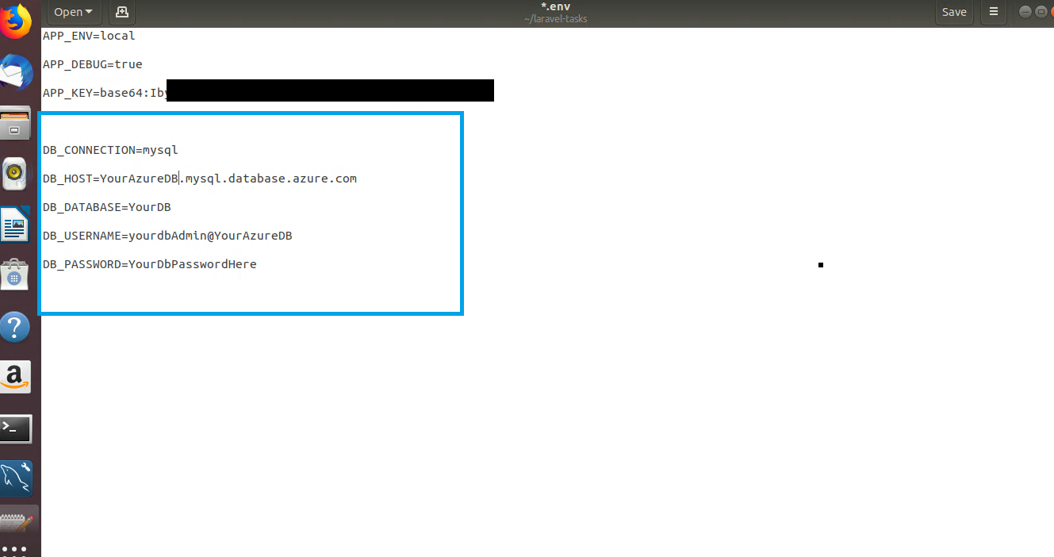

1. Edit the entries to the left and replace them with the connection information from the overview section for your Azure Database server.

# **Create a Docker Container and copy the Site files.**

1. Move the Laravel-tasks folder to the machine with docker installed.
   1. In our case the Linux machine was configured in Hyper-V. We used the RDP connection to copy and paste a Zipped folder containing Laravel-tasks. Other methods such as FTP may be used as well
2. Create folder for your project copy the contents of laravel-tasks folder into it.
3. Create a file named dockerfile (no extensions)
4. Open the file using notepad and add the following lines.
   1. FROM php:7.2-apache  
      COPY . /var/www/html/  
      run chmod -R 777 /var/www/html  
      run docker-php-ext-install pdo pdo_mysql
5. You should end up with something similar to the screenshot below.

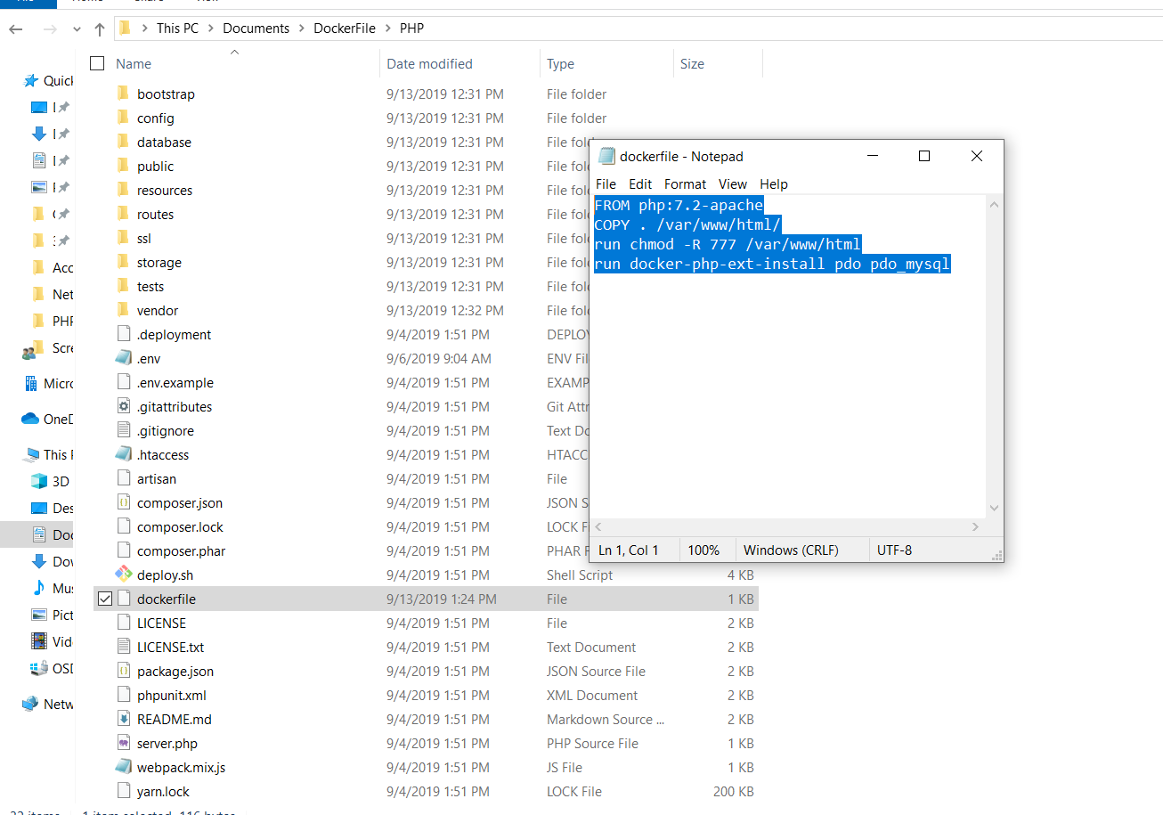

1. Open a command window or PowerShell in this folder and enter the following command to build a container with app files from the PHP official image, then enable the PHP database extension.
   1. docker build -t php/task:1.0 .
2. Move to visual studio code and find the docker image the click **Run Interactive.**

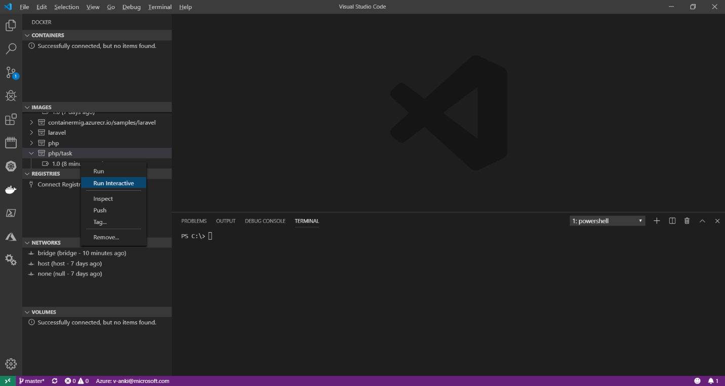

1. If you receive an error related to network use the up arrow to retrieve the command. After –**p** change port on the left to port other than 80. For example, **-p 888:80**
2. Right click the running container and select **Attach Shell.**
3. In the shell session enter the following command:
   1. a2enmod rewrite && apt-get update && apt-get install vim && vim /etc/apache2/sites-enabled/000-default.conf
4. The previous command installs vim and opens the default site configuration. Add **/public** to the document root and save.
5. Type **exit** to escape the container shell session.
6. To save the changes to your container find the friendly name (found next to container instance) and type:
   1. Docker commit friendly_name php/task

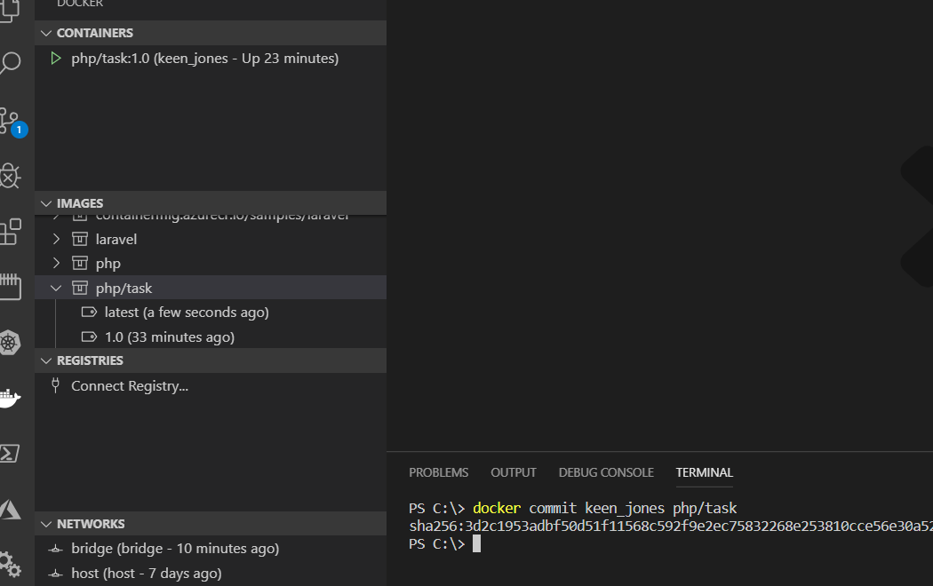

1. Now that the container has been updated restart the container. The site should now be exposed on port 888.
2. Navigate to the site by typing **localhost:888**

# **Upload your container to Azure Container Registry**

In this step we will push the container image from your local workstation to the Azure container registry.

## **Login to the registry**

1. Retrieve the login info from the Azure Portal by navigating to the container registry and clicking the **Access keys** blade. This contains the information needed in the next step. (Note you may need to **Enable** the admin user.)

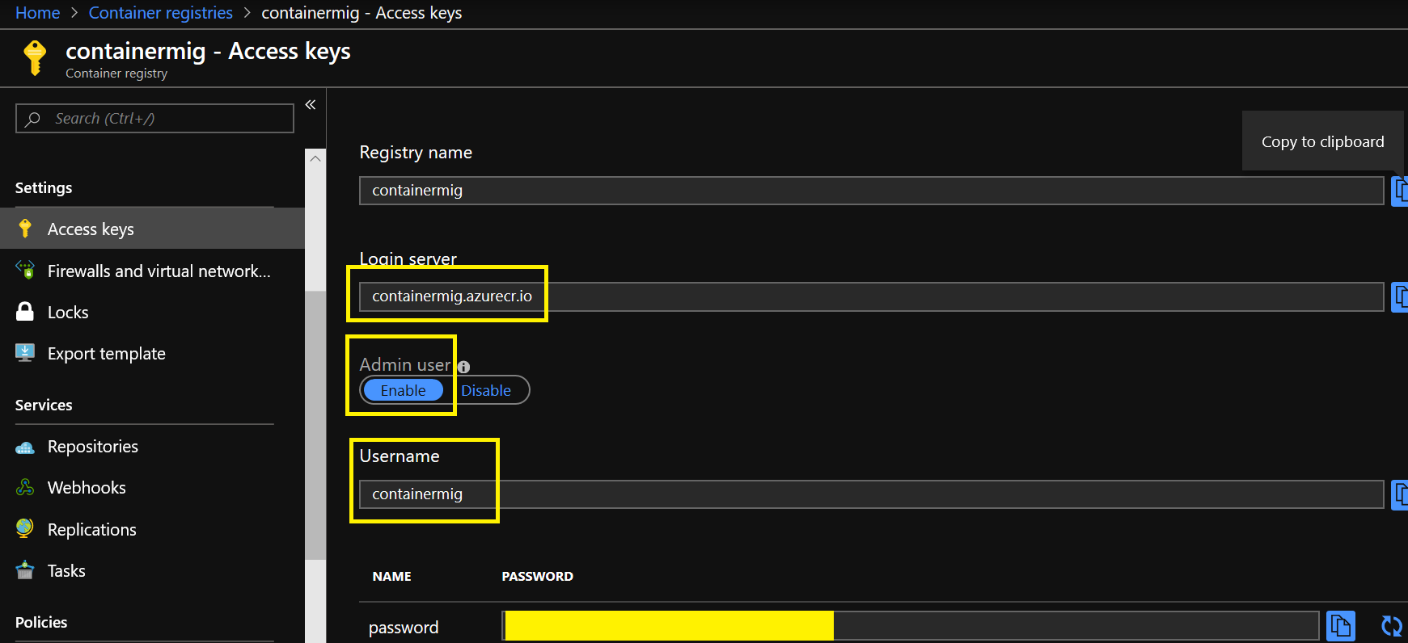

1. On your Docker Workstation enter the following command to login. (Replacing myregistry with the information from your access key page)
   1. docker login myregistry.azurecr.io
2. You will be prompted for the credentials.

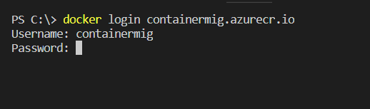

1. Tag an alias of the Docker image with the ACR information by entering the following command. (Replacing the php/task and myregistry with your settings.)
   1. docker tag php/task myregistry.azurecr.io/samples/task

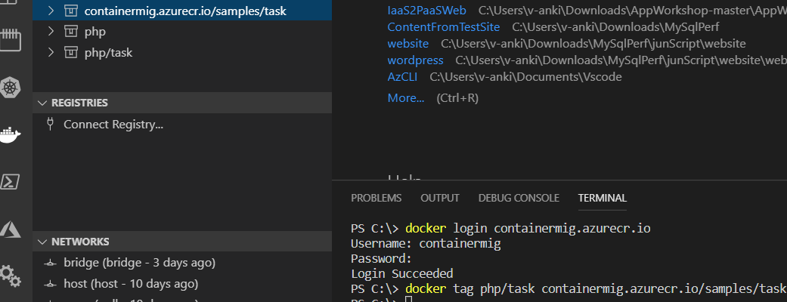

1. Next, we will push the tagged image to ACR. With the following command
   1. docker push myregistry.azurecr.io/samples/task
2. Navigate to your container registry and the container will now show up.

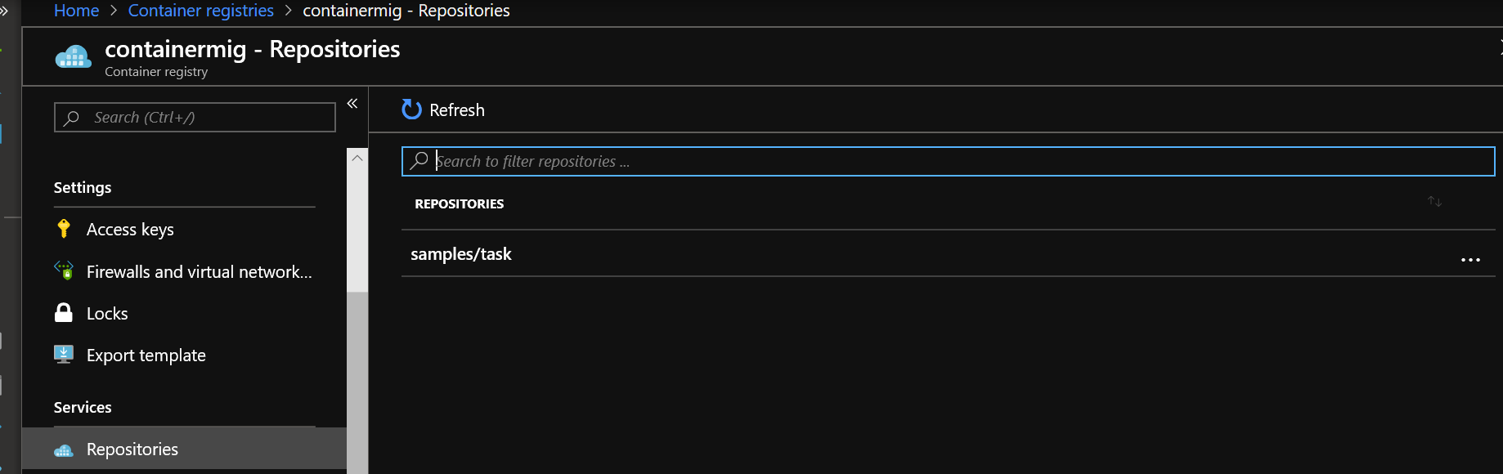

# **Create a Web App using your container**

1. In the Azure Portal click the **+** to create a new resource and select **Web App for Containers.**

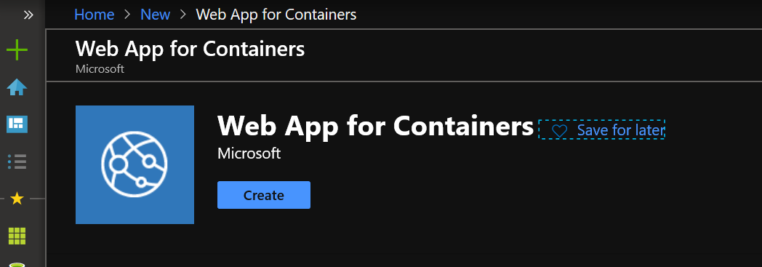

1. Choose the basic settings configure the app, plan, resource group settings. then click **Next: Docker >**

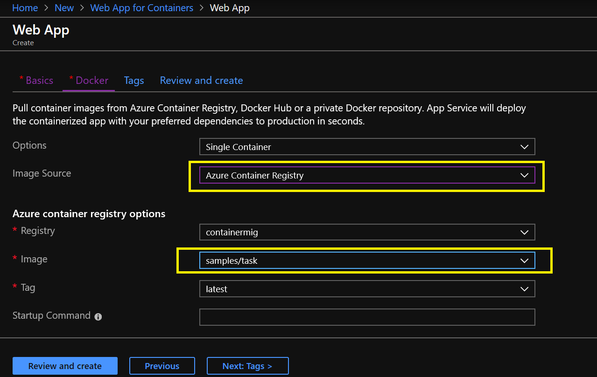

1. Specify the **Image Source** as **Azure Container Registry.** (Note if only 1 image is in the registry it should automatically default to that image.)
2. Click **Review and create.**  Then create the web app.
3. The app is now available at the Web App URL.

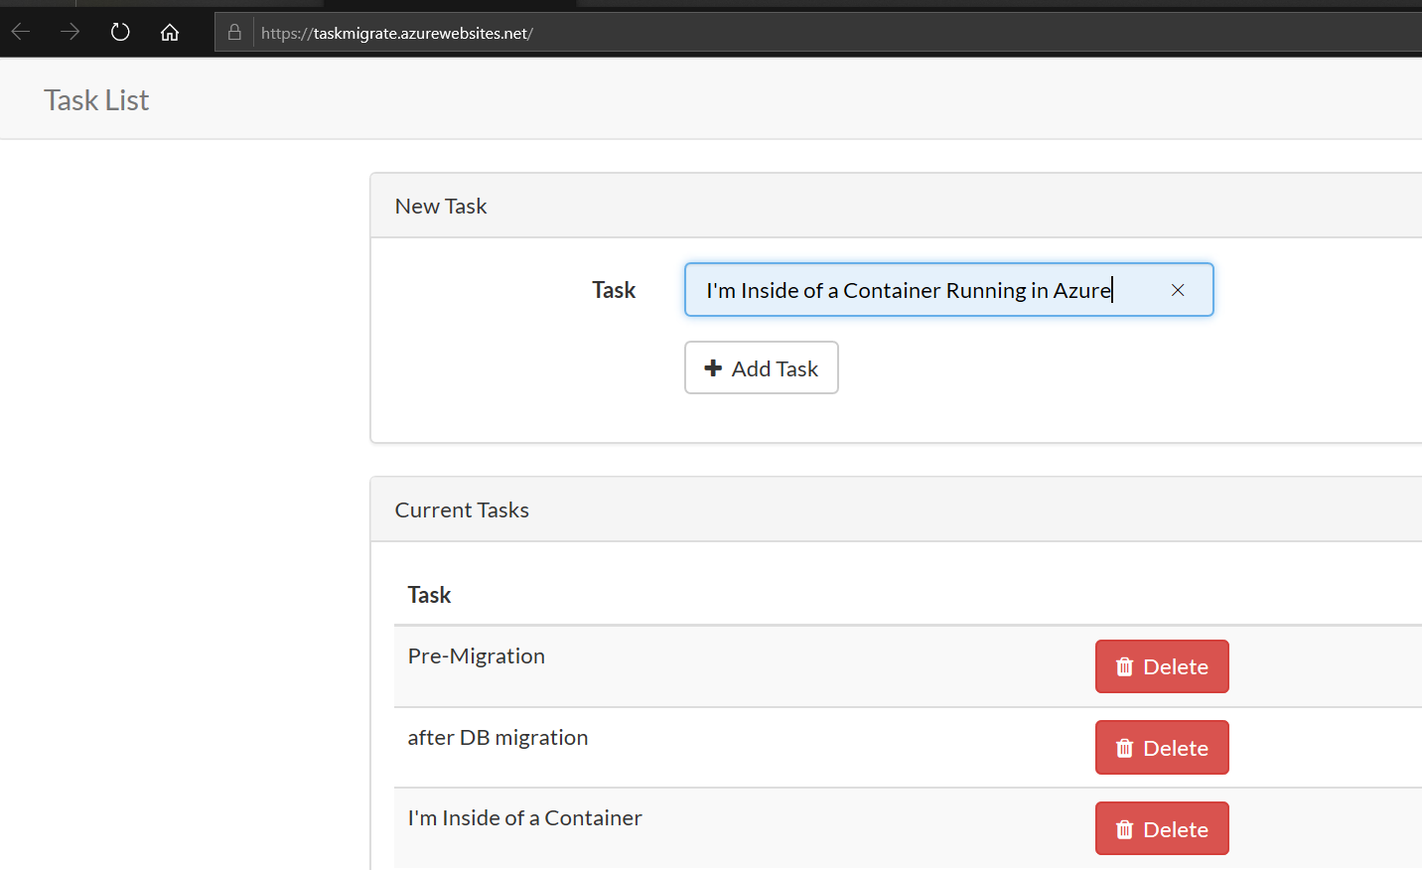

1. For added measure we can create new task.

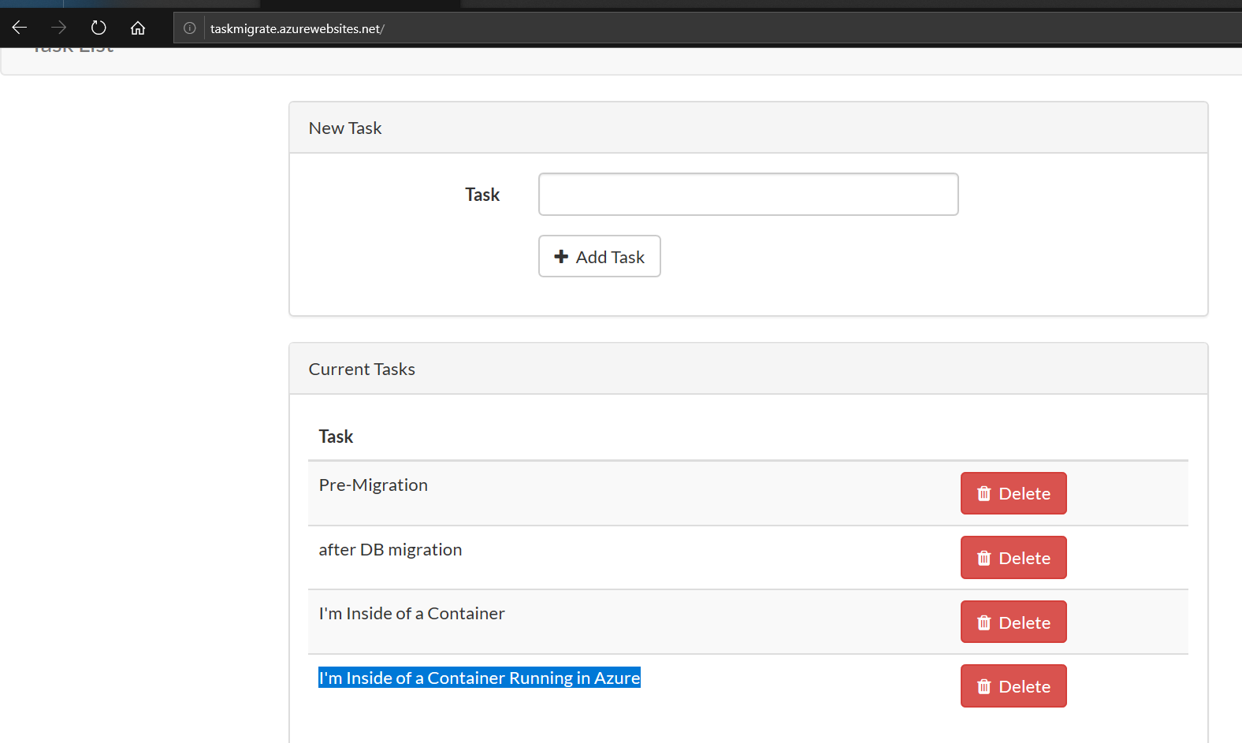

**Additional information:**

* [QuickStart: Build and run a container image using Azure Container Registry Tasks](https://docs.microsoft.com/en-us/azure/container-registry/container-registry-quickstart-task-cli)
* [Tutorial: Create a container image for deployment to Azure Container Instances](https://docs.microsoft.com/en-us/azure/container-instances/container-instances-tutorial-prepare-app)
* [About registries, repositories, and images](https://docs.microsoft.com/en-us/azure/container-registry/container-registry-concepts)